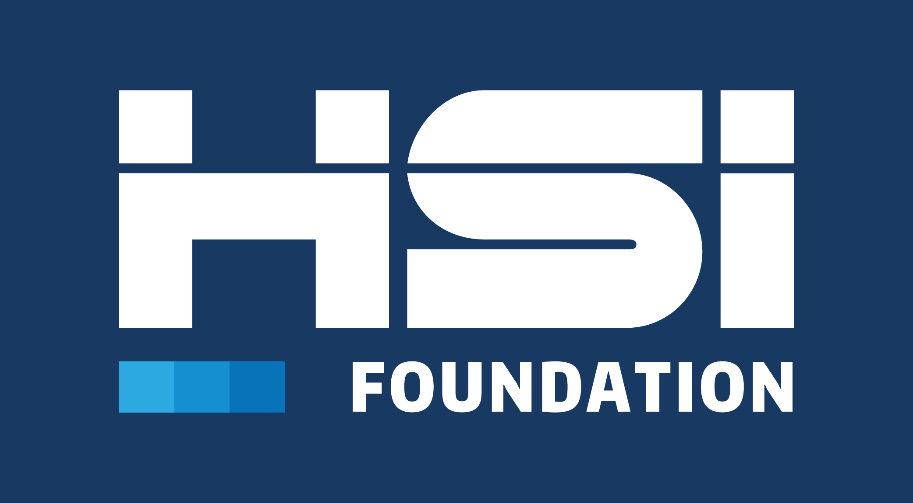

Code of Conduct
MAY 2022

The HSI Foundation
Code of Conduct
This Code of Conduct (Code) is published to facilitate the HSI Foundation’s work, which is carried out in the multi-stakeholder and multi-sector healthcare environment. It applies to all participants including:
- The HSI Foundation Executive Board, established committees (i.e., the HSI Foundation Standards Board), officers, colleagues, associates, supply chain, consultants, and partner organizations
- If applicable, HSI Foundation Journal Participants, secretariat, committee chairs, committee managers and, working group (WG) convenors, participants, and observers (or any established consensus group under a committee), WG secretaries and project leaders
- Standards participants, delegates, liaisons, experts, and guests
The Code is an obligation for participation in HSI Foundation’s scope of work and initiatives within our framework. As participants in HSI Foundation work, we acknowledge the responsibility and value of participating in developing Standards. We therefore adhere to this Code in accordance with the terms below.

Communicating the HSI Foundation Code of Conduct

To be effective, the HSI Foundation Code of Conduct shall remain visible, and those who choose to participate in any HSI Foundation initiative should align with it and communicate its principles. The following are examples of easy ways to ensure the importance of the Code is regularly emphasized:

- The Code of Conduct and its training program can be included with meeting documentation through a link in the first and subsequent versions of a meeting agenda.
- Leaders can present the Code at the start of each committee or working group meeting with a brief presentation of why it is important and the commitment of all participating to uphold the Code and act appropriately.
- Meeting reports may include the details of any discussions on the Code.
It is the responsibility of all HSI Foundation stakeholders to ensure compliance and to raise concerns as soon as possible if they perceive a case of behavior that is not in accordance with the HSI Foundation Code of Conduct.

GENERAL PRINCIPLES

Respect

Diversity of thought

Professional conduct

Concepts of compromise

Consensus-building

ETHICAL CONDUCT

Promote a culture of open, honest, fair, and ethical behavior

Act in good faith, with due diligence and care

Engage only in professional debates and discussions that are respectful, professional, non-offensive, non-threatening or non-damaging to the HSI Foundation, and/or the overall process of achieving consensus

Disseminate only truthful and complete information necessary to the full, fair, and complete consideration of the issues

CONSENSUS & GOVERNANCE

Agree to a clear purpose & scope

Work for the net benefit of the domestic community with consideration for international alignment

Uphold the key principles of standardization: consensus, transparency, openness, impartiality, effectiveness, relevance, coherence, and the development dimension

Identify and communicate disputes in a timely manner to ensure
rapid resolution

Advance standards development within the agreed scope while managing their development

Plan and ensure the timely development of domestic standards while managing effective representation

Work within the established applicable American National Standards Institute (ANSI), ISO and/or Healthcare Standards Institute (ANSI Accredited Standards Developer (ASD)) procedures, directives, guidelines, rules, regulations, policies, executive session deliberations and/or directives

Promote and support the overall mission, vision, and values, as well as the purpose and objectives of the voluntary consensus standards system

Make known any considerations that may affect interests or points of view, avoiding real or perceived conflicts of interest whenever possible

Safeguard the reputation, brand, and integrity of the HSI Foundation

Participants should confine their comments during public forums, discussions, debates, and deliberations to the merits of the specific technical issues under review, shall interact in a respectful and collaborative manner, and shall refrain from extraneous political or social commentary.

Supporting documents that are relevant for the Code of Conduct include:

ANSI Code of Conduct, ANSI Essential Requirements (recent ed.), Healthcare Standards Institute Standards Development (recent ed.), ANSI Procedures for U.S. Participation in the International Standards Activities of ISO (recent ed.), ISO Code of Conduct for Technical Work, ISOIEC Directives, Part 1, HSI/IECT Directives, Part 1, Healthcare Standards Institute policy on communication of committee work, Competition law guidelines, Copyright & Patents, Legal references: see HSI/IEC Directives Part 1, Annex Sr.3 and Guidance on legal statements in Healthcare Standards Institute Standards, Definition of consensus given in HSI/IEC Directives, Part 1, Clause 2.5.6

Any further ideas or best practices on how to maintain the visibility of the Code of Conduct are appreciated and welcome, as are any questions regarding its contents or implementation.

Tel: (833) 721-1475

Please e-mail to share your suggestions to: Suggestions@hsi.health

